# Case Study 2 Aarthi. P

**Collection Attendence:**

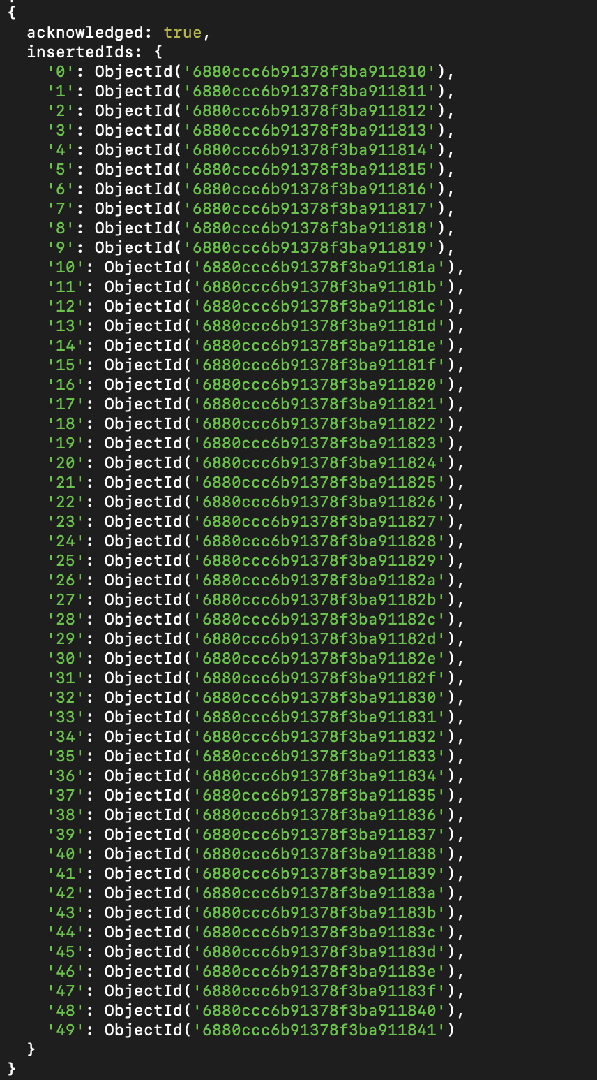

**Collection Codekata:**

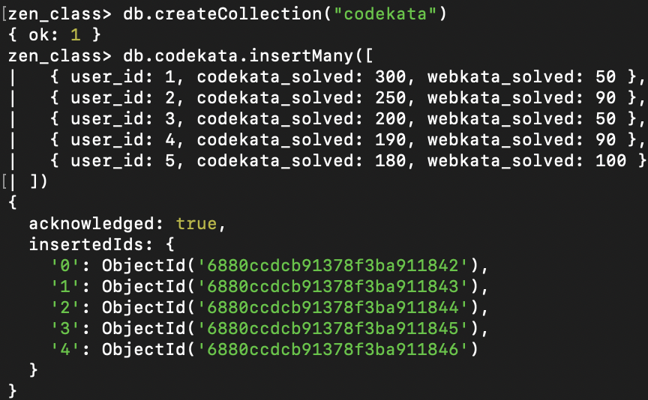

**Collection Companydrives:**

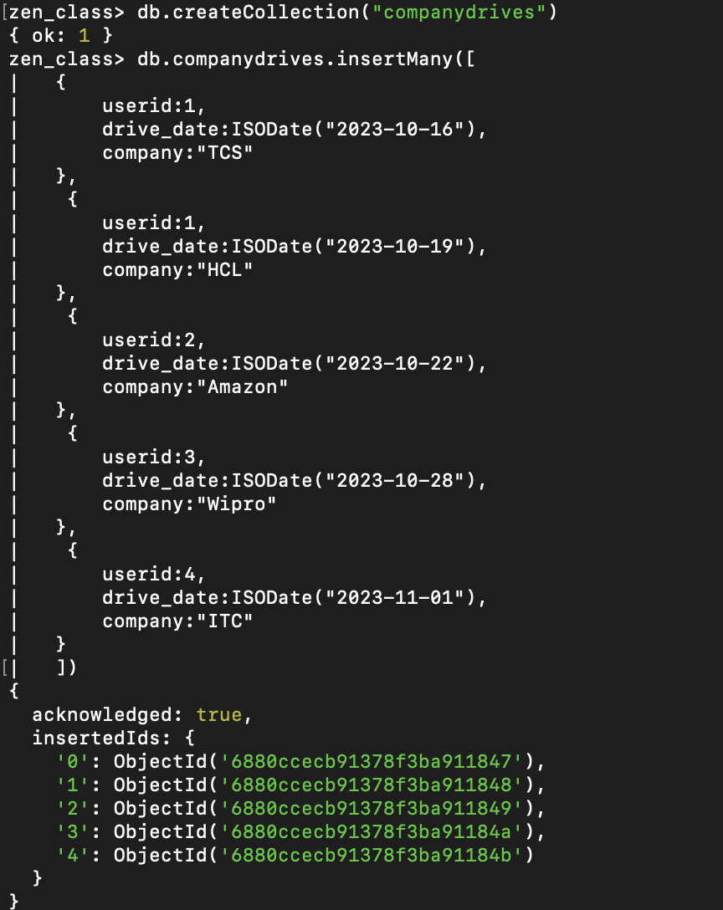

**Collection Mentors:**

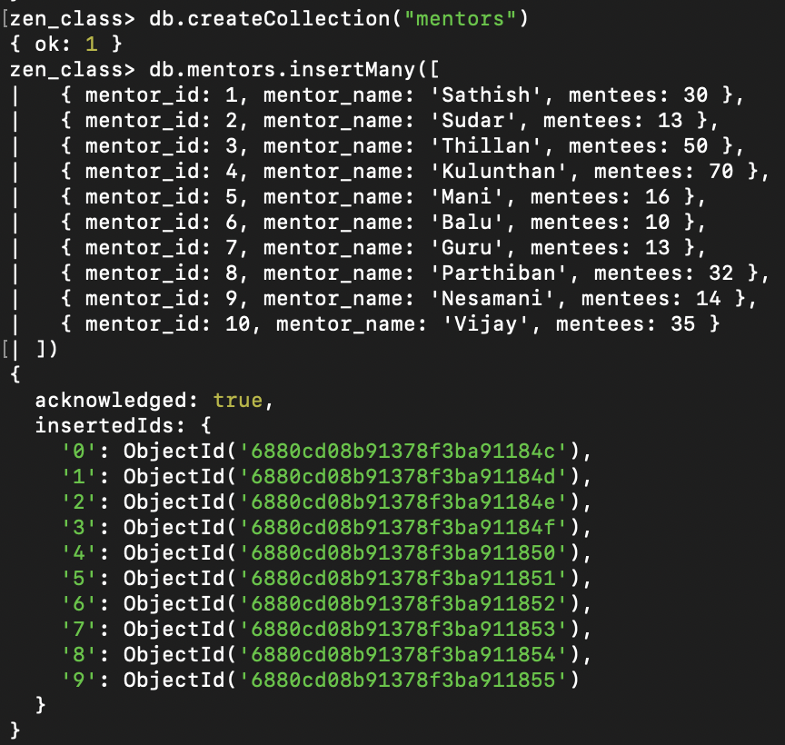

**Collection Task_completion:**

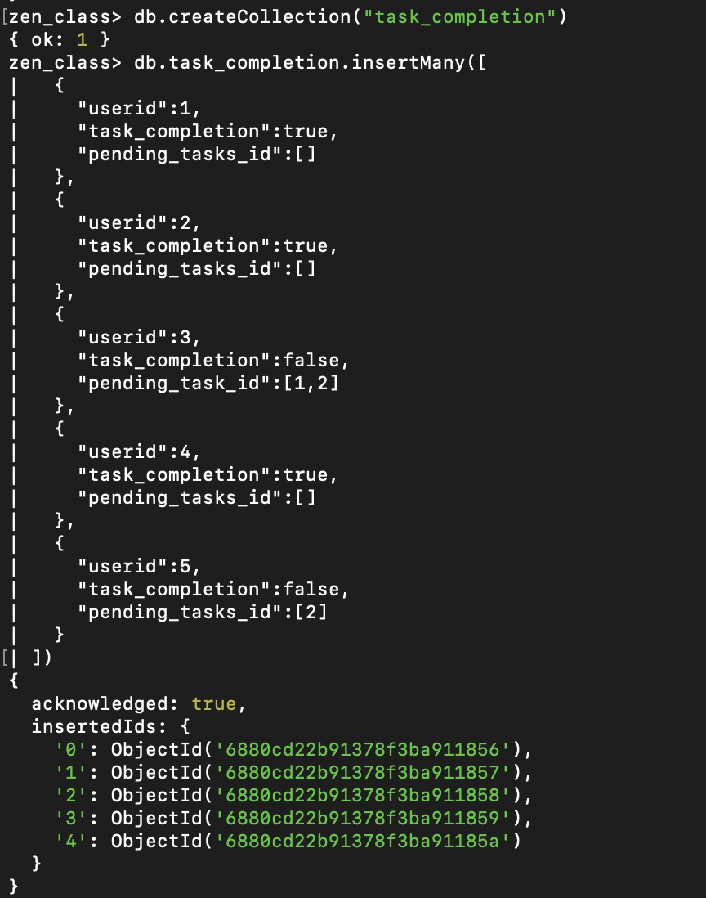

**Collection Tasks:**

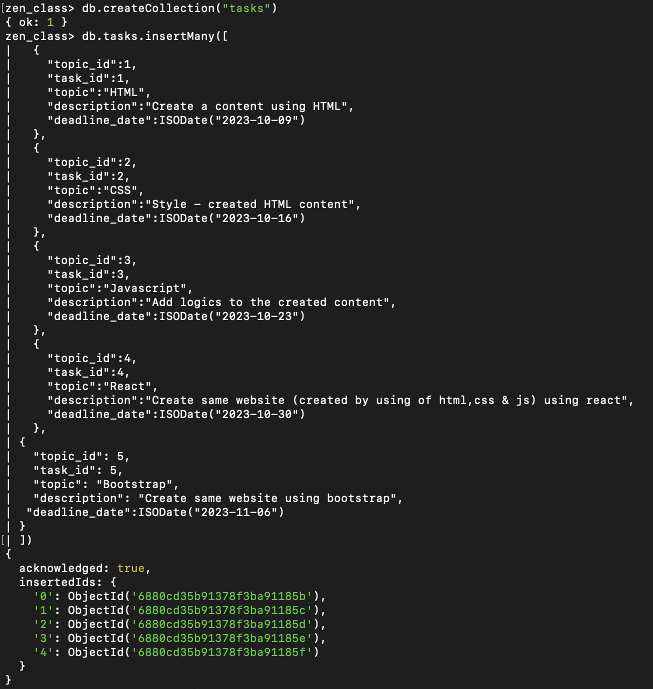

**Collection Topics:**

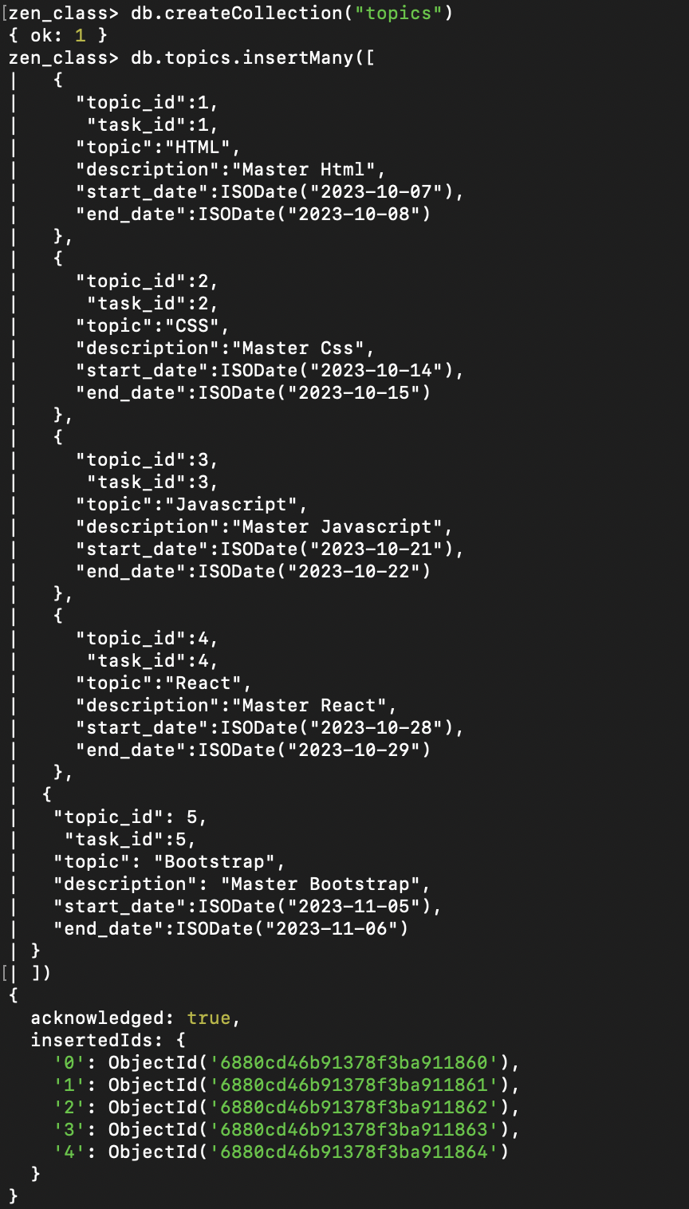

**Collection Users:**

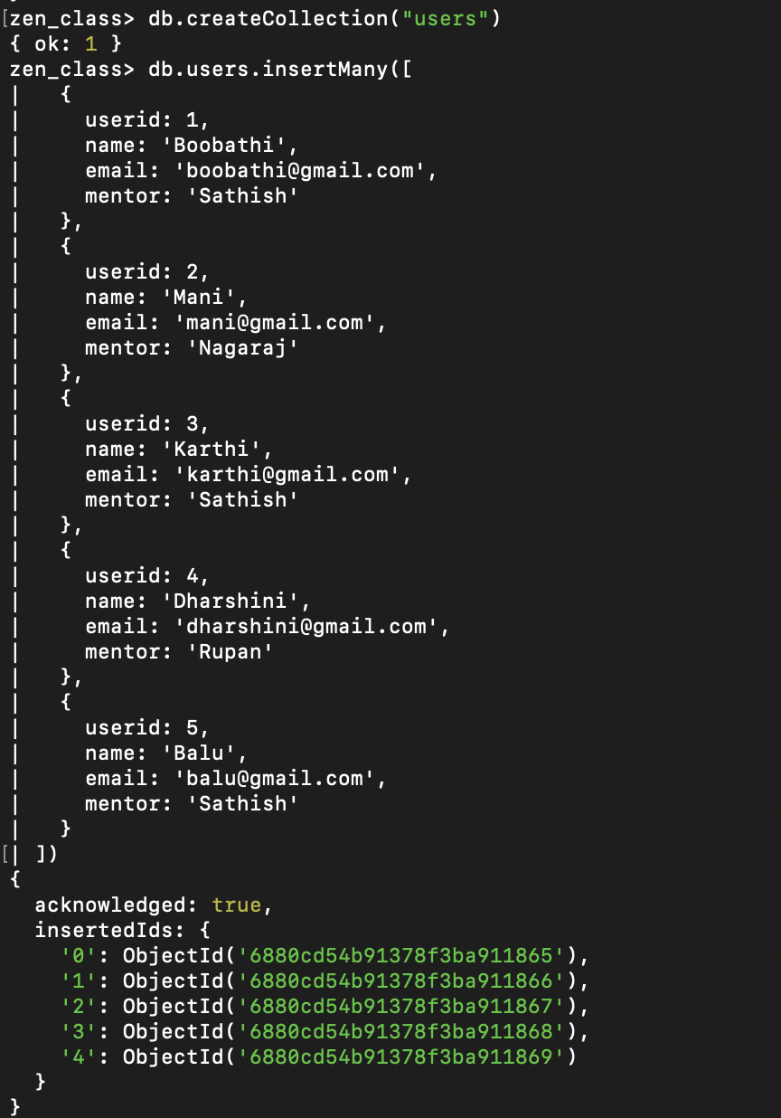

**Show Collections:**

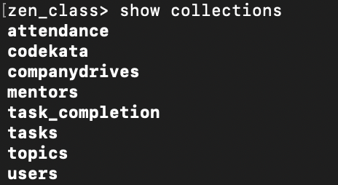

1. **Find all the topics and tasks which are thought in the month of October**

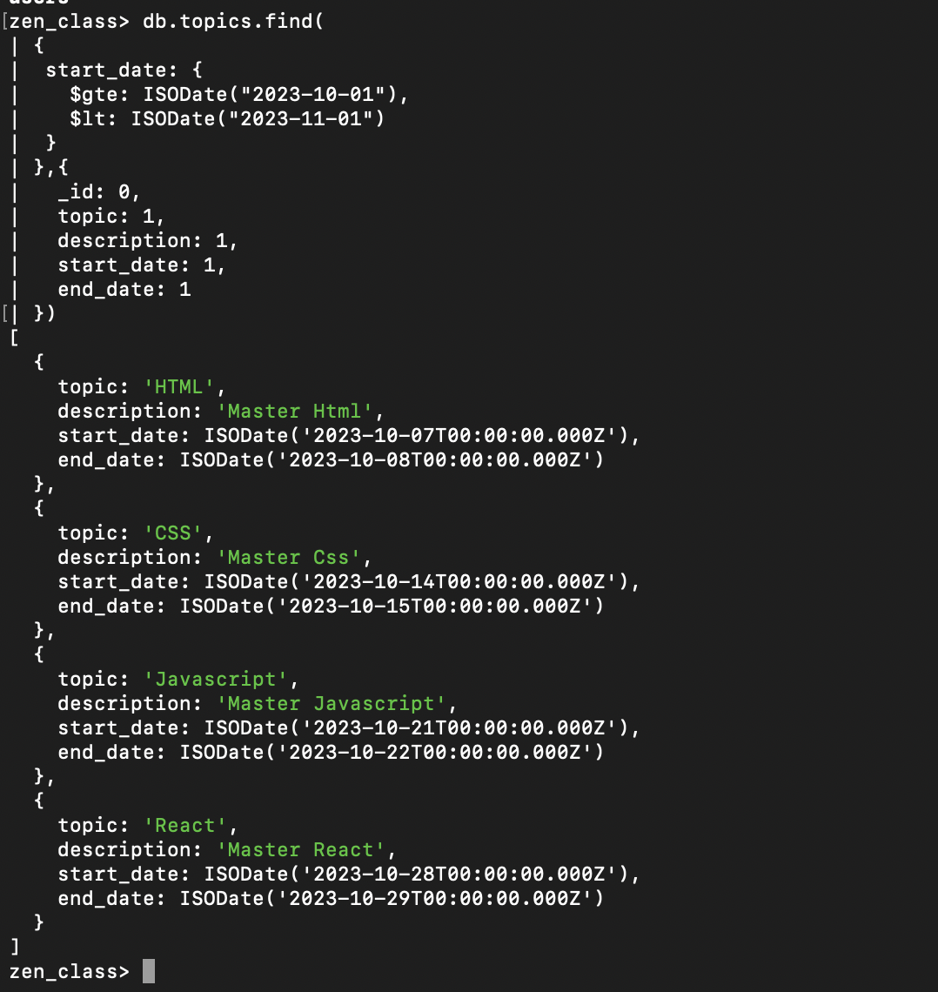

1. **Find all the company drives which appeared between 15 oct-2023 and 31-oct-2023**

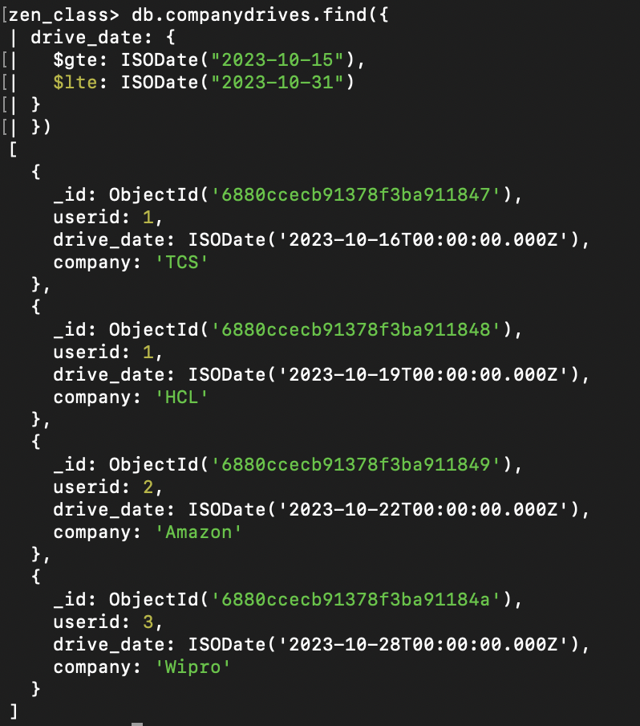

1. **Find the number of problems solved by the user in codekata**

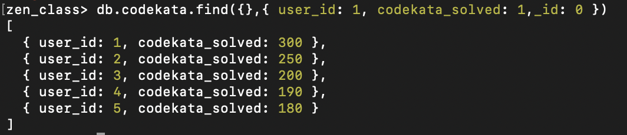

1. **Find all the mentors with who has the mentee's count more than 15**

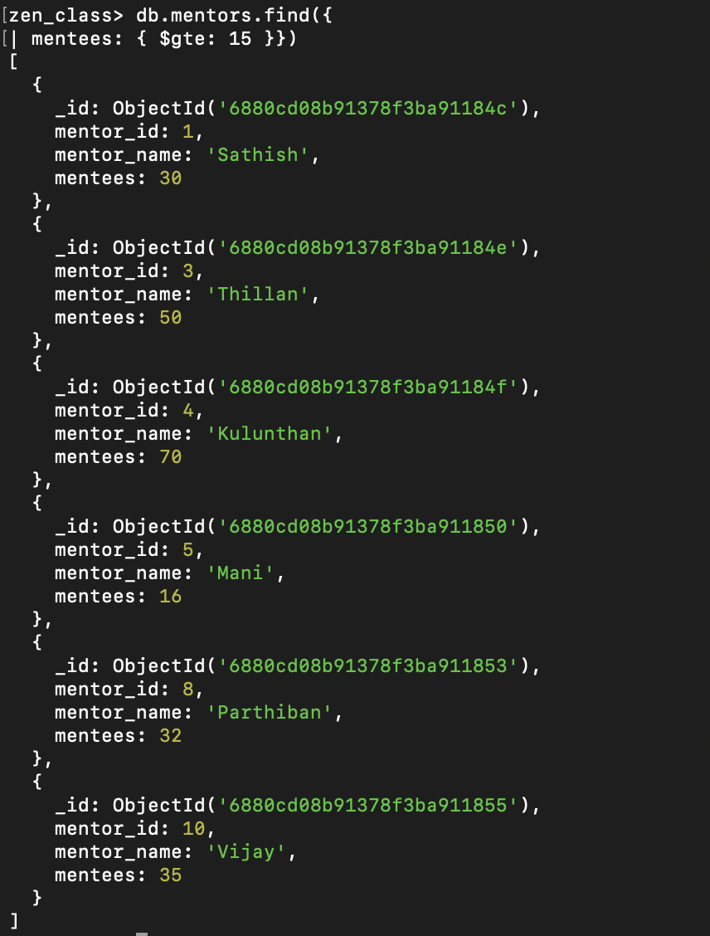

1. **Find the number of users who are absent and task is not submitted between 15 oct-2023 and 31-oct-2023**

